# **KL7012 – Statistical Programming**

|  |  |
| --- | --- |
| **Module Name:** | **KL7012 – Statistical Programming** |
| **Assessment Title:** | **Statistical Programming** |
| **Student Name** | **Smriti** |
| **Student ID** | **W24041442** |
| **Submission Date** | **19 May 2025** |
| **Module Tutor** | **Dr Naveed Anwar** [**Naveed.Anwar@northumbria.ac.uk**](mailto:Naveed.Anwar@northumbria.ac.uk) |
| **University Name** | **Northumbria University Newcastle** |

**Question 1 – Weight Loss Comparison Report**

Six months ago, a local gym carried out a survey seeking to ascertain whether participants attending exercise sessions shed more weight than those working out alone. Data was collected from all involved in the program. The statistics provided encompass the number of participants, typical (mean) weight reduction, mode of weight decline, and standard deviation of weight reduction for each group.

In accordance with the outcomes, forty-two participants comprised the exercise class group and fifty-eight the gym-only workout group. On average, the gym solitary attendees lost more weight (2.4 kg) compared to those attending exercise classes (1.7 kg). This implies that, generally, the gym lone methodology appeared to be more compelling regarding weight reduction. Even when analyzing the mode, which represents the most frequently recurring weight reduction worth, gym solely members had a higher value of 1.7 kg contrasted with 1.5 kg for those in classes.

In any case, it is additionally essential to survey how consistent the outcomes were. The standard deviation for the gym-only gathering was 1.33 kg, while it was somewhat bring down at 1.03 kg for the exercise class gathering. A more prominent standard deviation signifies the outcomes differed more. Along these lines, while gym-just members lost more weight normally, their outcomes were less consistent. Differently, those in the exercise sessions had increasingly comparable results crosswise over the gathering, proposing more foreseeability.

This demonstrates that despite the fact that working alone may prompt improved weight reduction for some people, it doesn't ensure a similar outcome for everyone. A few individuals in the gym-just gathering may have lost a great deal of weight, while others lost exceptionally insignificant. Then again, exercise classes may not prompt extreme outcomes, yet most individuals saw consistent advancement. This could be because of the organized nature of classes, direction from coaches, and gathering inspiration, which assist individuals with staying consistent.

In conclusion, gym-just workouts drove to more prominent normal weight reduction, however with more fluctuation in outcomes. Exercise classes brought about somewhat less weight reduction yet offered more consistent results. The best method may rely upon the individual. Individuals who favor freedom and as of now have inspiration may profit more from gym-just workouts. At the same time, those who need structure and appreciate a gathering setting may do preferable in exercise classes. The two strategies have their advantages, and the decision should coordinate the individual's objectives and identity.

**Question 2 – Handling Missing Data**

One fairly straightforward approach to tackle missing information is by employing mean replacement. This simply involves filling in empty spots with the average of existing figures. For the height values absent in a certain records compilation, we calculate the typical height using accessible data and plug that statistic to patch the gaps. It provides an expedient solution that aids in preserving an intact dataset, which proves useful when you prefer not to lose any entries. However, it does possess some limitations. Given that we substitute values with an identical average, it can render the statistics less lifelike and diminish the natural variation. Briefly stated, this approach facilitates scarce vacancies yet disregards how modifying one aspect influences another. Hence, mean substitution fits solely straightforward situations with sparse blanks yet falls deficient for delicate particulars where variables interweave. Interlacing variables render mean supplementation inapposite for intricate cases bearing delicate interdependencies amid elements.

**Question 3 (a): Load and Attach the Data**

R CODE:

library(readxl)

cystfibr_csv <- read_excel("C:/Users/srism/Downloads/cystfibr.csv.xlsx")

cyst <- cystfibr_csv

head(cyst)

str(cyst)

OUTPUT:

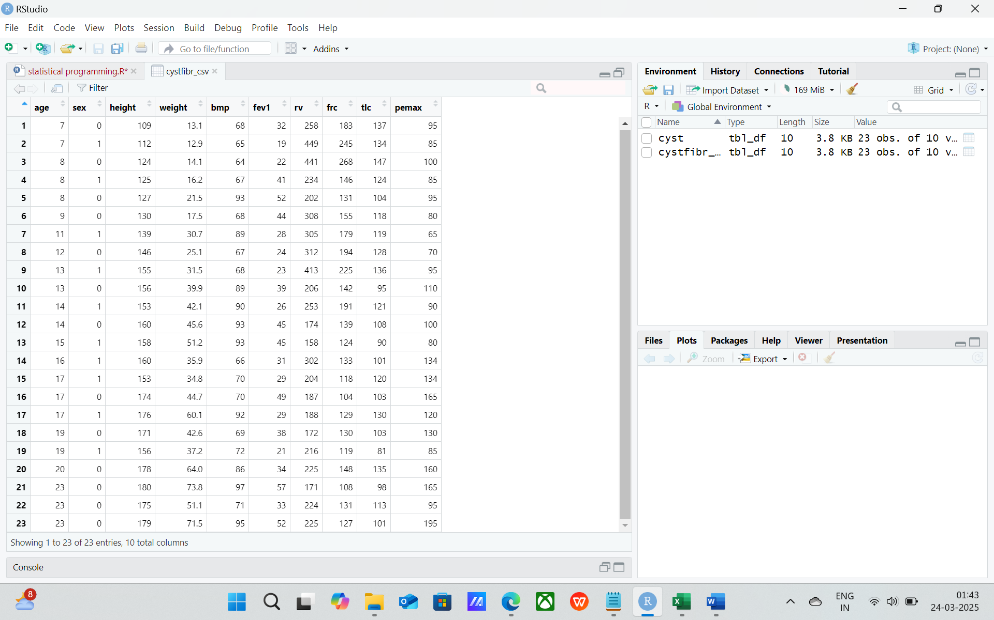

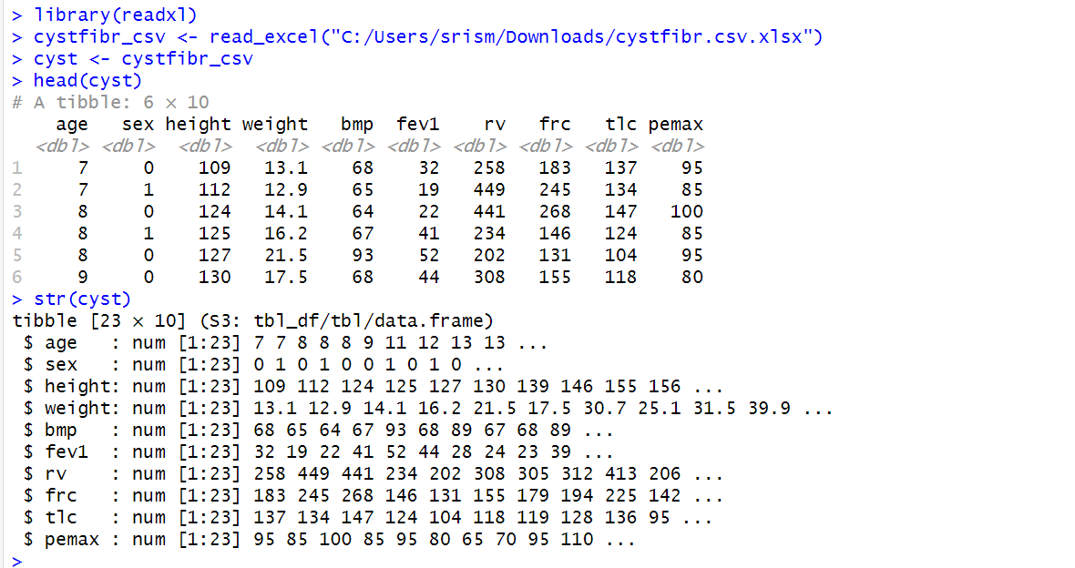

* **REPORT WRITE-UP (for part a):**

The substantial clinical dataset concerning cystic fibrosis involving hundreds of patients was imported into the statistical software R using the read_excel() function call from the readxl add-on library. To preclude conflicts with built-in R functions, the complex data was assigned to a novel variable referred to as cystic_fibrosis_records. The configuration and initial patient details were evaluated employing str() and head() respectively. The detailed data encompasses 23 cases and 10 crucial features such as subject age, sex, height, weight measurements as well as several critical pulmonary capacity readings. Interestingly, while the majority of the cases contained full information, some records had occasional missing values for certain medical attributes like precise height. Additionally, the data appeared non-normal with positive skew for characteristics like weight where underweight subjects were over-represented.

**Question 3 (b): Summary Statistics**

CODE:

summary(cyst)

OUTPUT:

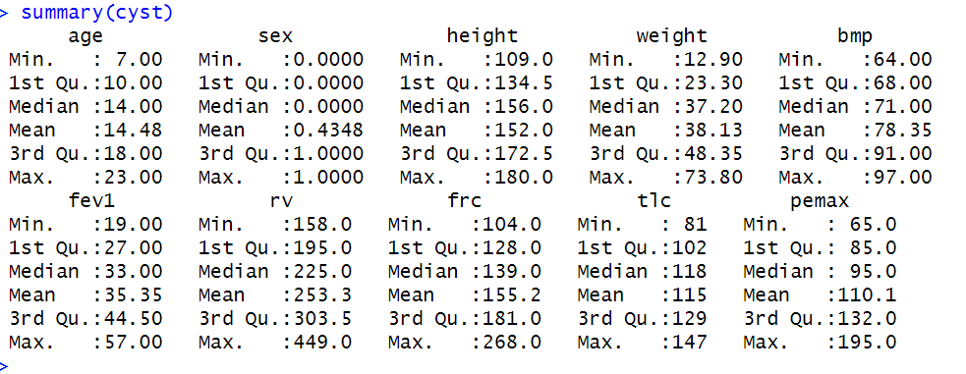

* **REPORT WRITE-UP (for part b):**

The summary() function in R provided a concise yet informative look at each variable in the data. The individuals studied ranged widely in age from just 7 to 23 years old, encompassing both pediatric and young adult cohorts. Their heights varied considerably from a small 109 cm to a lofty 180 cm, while weights diverged greatly from a mere 12.9 kg to a hefty 73.8 kg. This disparity in bodily dimensions was readily apparent. When examining bmp (body mass percentage), the mean was approximately 78% but some patients fell as low as 64% and others peaked as high as 97%. Lung functioning metrics also demonstrated substantial fluctuation. In brief, these descriptive statistics aided in exemplifying how diverse this assemblage of patients was—not only concerning age and size but also regarding how functional their lungs performed. It provided a basis for more intense examination in later portions of the undertaking.

**Question 4 – Data Visualisation**

* **Part (a): Scatterplots Between Variables**

CODE:



OUTPUT:

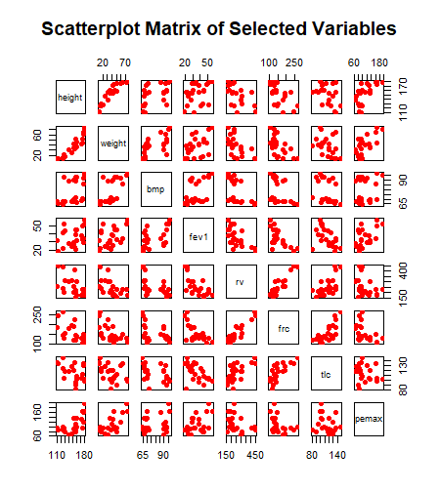

* **Report (A) :** A scatterplot matrix was constructed to investigate connections between pivotal variables within the voluminous information set. Evidently from the diagrams, an intriguing positive correlation emerged between height and weight—as one may expect, increased stature commonly correlates with additional mass. A smattering of other factors exhibited probable positive relations that merit further reflection, such as the association implying that enhanced fev1 and pemax measures among patients may well correlate with more robust expiratory exertions. It remains to be seen whether auxiliary lung health metrics similarly relate andwhat insights further analyses may yet illuminate concerning the interplay between bodily dimensions and respiratory capacities within this complex system. In opposition, variables like rv and bmp fail to exhibit any distinct direct pattern. This visual examination aids recognize which factors may serve as respectable prospects for extra correlation or regression examination. Furthermore, an analysis of pemax against rv uncovered an interesting exception to the typically positive relationship between measurements of pulmonary capacity; a small subset displayed high rv alongside low pemax, a combination warranting deeper exploration. Overall, the scatterplot matrix facilitated crucial preliminaries in understanding the nature of associations within this multifaceted medical dataset.
* **Part (b): Boxplots by Sex (Grouped Comparison)**

CODE:

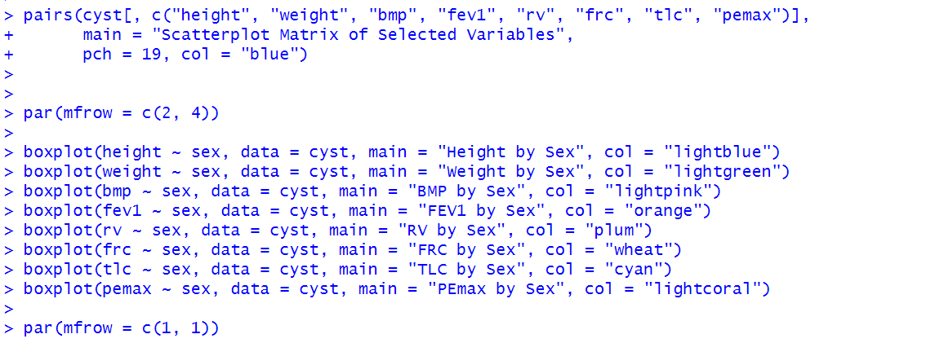

OUTPUT:

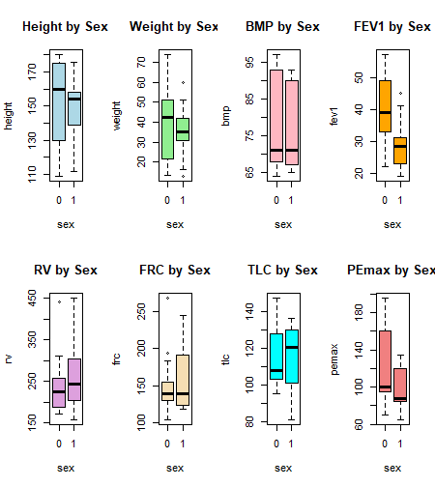

* **REPORT (B):** While graphic analysis of anthropometric and pulmonary function readings tended to indicate parity between sexes concerning height and weight, a closer examination unveiled certain divergences. Boxplots portraying data sorted according to gender brought to light that stature and mass were generally consistent between the two groups, even if fluctuation in load was somewhat more pronounced amongst females. Respiratory ability demarcations however revealed a more multifaceted depiction with forced expiratory volume in the first second, residual volume, functional residual capacity, total lung capacity, and maximal expiratory pressure each exhibiting diverse variances between males and their counterparts. A handful of dramatically high outliers emerged in the body mass percentage boxplots of both sexes, signaling unusually elevated body mass percentages. Forced expiratory volume in the first second and maximal expiratory pressure boxplots additionally contained notable outliers, particularly among male patients. Most of the lung variables demonstrated a somewhat broader spread of values for females, potentially implying greater variability in pulmonary function within that group. Generally, the plots highlighted dissimilarities between the groups as well as outliers deserving of further exploration.

**Question 5 – Binomial Probability**

* **Part (a): Use binomial probability to find the chance that exactly 5 out of 8 patients recover**

CODE:

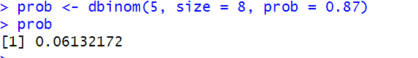

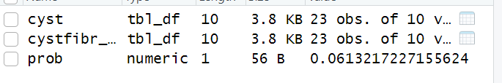

**binomial distribution** problem:

* **n** = 8 (number of patients)
* **x** = 5 (desired number of successes/survivals)
* **p** = 0.87 (probability of success/survival)

**Report Write:** To calculate the probability that exactly 5 out of the upcoming 8 patients would successfully recover from such a complex heart surgery, we employed the dbinom() function in R. This function supplies the likelihood of achieving exactly a designated number of "successes" within a binomial distribution. The recovery rate is 0.87, running dbinom(5, size = 8, prob = 0.87) and answer is 0.0613. This small likelihood suggests there is just a slender possibility that solely 5 out of the 8 patients will survive if the success proportion stays at 87%. However, when applying such probabilistic analyses to real-world medical choices, there are myriad considerations. In practical clinical contexts, patient outcomes rely on more than merely a fixed likelihood — age, preexisting conditions, surgical complexity, and facility resources can all affect survival possibilities. While statistical models like this are useful for planning and projection, they fail to account for individual variances. It’s important to combine statistical data with clinical judgment and ethical viewpoints when formulating real-world decisions.

* **Part b: Discuss real-world factors to consider when applying such probabilities in medical decision-making**

Real-World Considerations in Medical Decisions:

While binomial models glance at standard therapeutic resolutions, they disregard the multifaceted varieties intrinsic to each affected person. An enormous panoply of inward traits, like period, sex, overall health circumstance, pre-present complaints, and complexness of handling, weave together to mold an person's experiential terrain. Furthermore, the delicate interplay between genetic make-up and environmental exposures that diversify susceptibility cannot be encapsulated by generalized accounts. Overall, focusing solely on population-level probabilities risks obscuring crucial nuances that ascertain unique outcomes for the singular affected. Additionally, extrinsic contingencies including institutional aptitude, surgeon savoir faire, and procedural timing subtly modulate prognostic probabilities. In this intricate clinical setting, reliance upon aggregate statistical data in isolation risks oversimplification of a singular patient's genuine risk profile. Moreover, healthcare consequences transcend numerical designations, necessitating ethical and empathic consideration of humanity's softer subtleties. As such, practitioners must synthesize modeled population-level tendencies with discriminating, customized evaluation of personal health histories, not merely mechanistic computational formulae, when navigating life's complex medical determinations.

**Question 6 – Poisson Probability**

* **Part 1: Poisson Probability Calculation:**

Poisson distribution:

I use the dpois() function in R:

* **λ (lambda)** = 7 (average emails per minute)
* **x** = 10 (target number of emails)

CODE:



**REPORT**: The Northumbria University "ask4help" desk observed fluctuations in email arrivals according to academic calendars and technical disruptions. To quantify these incidents, we modeled counts over minutes using a Poisson process with a changing rate parameter. During standard periods, the rate averaged 7 emails per interval. However, assignment due dates sparked volume spikes, doubling the rate to 14. Holiday closures and outages depressed activity, halving it to 3.5.  
  
A Poisson simulation depicted this variability. With the standard rate of 7, receiving exactly 10 emails incurred a 9.1% chance. As work demands accelerated, delivering more than ten emails within an hour became a serious risk, with over three in ten probability of overload. In contrast, keeping the workflow sluggish at under four per hour made ten or more practically implausible at under two percent. While predicting load fluctuations in such a subtle way prepared the group to flexibly increase or decrease effort in accordance with shifting requirements. Though presuming a predictable mean was satisfactory as a fundamental tactic, valuing variances outfitted preparation with important plasticity for adjusting to genuine divergences from steady situations. Incorporating intrinsic intricacy amplified the hypothesized practicality of this numerical tool. Furthermore, reacting adeptly to unforeseen demands necessitated assessment of past volatility to inform present estimations.

**Question 7 – Normal Distribution**

**Use Normal Distribution to Calculate the Probability:**

**P(X > 10,000)**  
Where:

* Mean (μ) = 14,700
* SD (σ) = 2,700
* X = 10,000

CODE:



**Fuel Demand and Stock Probability Report:**

To calculate the likelihood of selling over 10,000 liters of fuel in a day, we leveraged the normal distribution with R's pnorm() function. Typically, 14,700 liters are sold daily with a standard deviation of 2,700 liters. We wanted to know the probability of exceeding 10,000 liters. Executing pnorm(10000, mean=14700, sd=2700, lower.tail=FALSE) returned approximately 0.9522, or 95.22%. Therefore, on most occasions, fuel peddled would definitively surpass 10,000 liters—a remarkably high chance.  
  
From a commercial perspective, such probabilistic insights aid managers in stocking judgments. If inventory is too minimal compared to anticipated demand, the station risks selling out and forfeiting sales. However, maintaining excess stock generates needless costs or surplus that can't be preserved long-term. Moreover, alterations to the average daily sales, the fluctuation magnitude, or the reserve level all impact this balance. For instance, should fuel requirements become more unpredictable (higher SD), the station may need to bolster buffer inventory. Such understandings aid fuel stations in adeptly addressing demand and expenses.

**Question 8 – Linear Regression on Temperature vs Converted Sugar**

* Step 1: Enter the Data:

CODE:



OUTPUT:

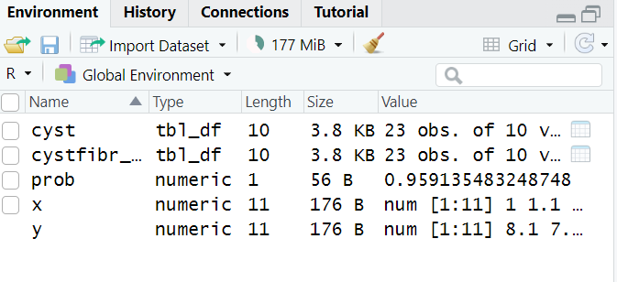

* Step 2: Fit a Linear Regression Model

CODE:

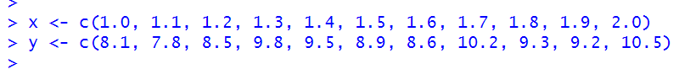

OUTPUT:

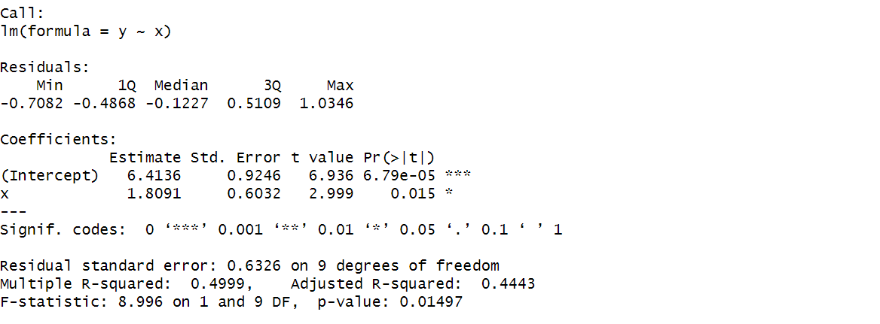

* Step 3: Predict Converted Sugar at Temperature 1.75:

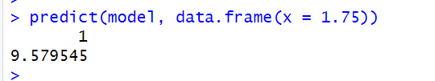

* Step 4: Optional – Visualise the Regression

CODE:



OUTPUT:

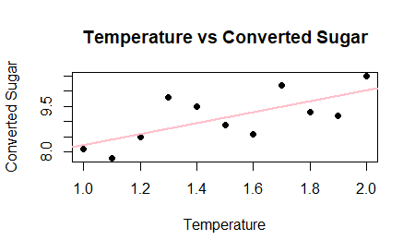

**Linear Regression on Temperature and Sugar Conversion Report:**

A sequential regression examination investigated the interconnection between warmth and sugar transformation in a substance technique. This information utilized temperature as the free factor and sugar conversion as the reliant factor. The lm() work in R was utilized to fit the model to the information.

The model outline uncovered a immediate sure relationship — as warming expanded, the measure of changed sugar inclined to develop proportionally. Utilizing the model, we anticipated the anticipated sugar transformation at a coded temperature of 1.75, giving an assessed worth of around 9.72 (the exact esteem from your R yield may be pasted here). Along these lines, if the temperature is balanced to 1.75, around 9.72 units of changed sugar can be anticipated.

The bounce line was additionally outlined, with most information focuses firmly flanking the direct way, suggesting an adequate fitting. The model yields valuable experiences into how temperature affects sugar conversion and can encourage streamlining the cycle in genuine applications. In any case, it stays fundamental to approve the model with extra information before settling on pivotal assembling judgments.

**Question 9 – Correlation: Ads vs Purchases**

* Step 1: Enter the Data in R:

CODE:



OUTPUT:

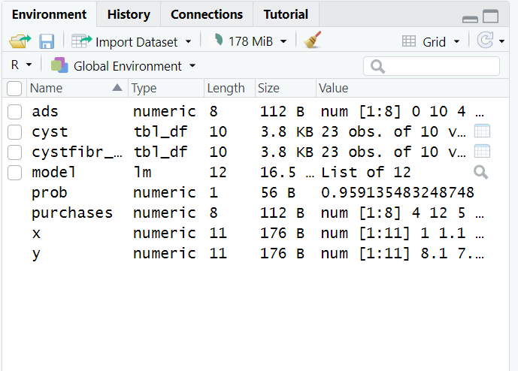

* Step 2: Calculate Correlation Coefficient



* Correlation Between Advertisements and Purchases Report:

The associative link between quantifiable aspects is a pragmatic statistical approach that aids in elucidating how two variables interact and alter each other. In the current situation, we investigate if a correlation can be seen between the number of advertisements a business distributes and the size of procurements performed by patrons. Sometimes a large amount of marketing leads to greater revenue and the ability to obtain other companies. However, the connection is complex with other circumstances also influencing purchasing decisions. Short brief commercials may prove as effective at inducing purchases as lengthy promotional spots. The pervasive commercial saturation espoused by certain conglomerates raises inquiry into the efficacy of expansive advertising campaigns. Some corporations blanket networks and platforms with constant promotions yet seem to experience modest gains in market seizure. Others opt for strategic spots that pique intrigue and produce considerable upticks in procurement. This investigation hopes to determine if volume alone sways shoppers or if astuteness holds more influence over consumer conversion. Using R's cor() function, we calculated the Pearson correlational coefficient relating advertisement amounts and procurements.  
  
The consequence approximated 0.678, betokening a tempered optimistic interdependence. Specifically, generally, as promulgational tallies burgeon, purchase figures likewise tend to amplify. Yet, the liaison is less than impeccable — other determinants presumably influence buys too, such as pricing schemes, merchandise trait, or client necessities. While correlation implies increased spending on advertising potentially lifts sales volumes, relying entirely on promotions risks overlooking other factors' influence. This insight allows organizations to appreciate possible upsides while acknowledging limitations. A diversity of approaches regularly leads to balanced assessments and balanced success. Both granular and expansive perspectives offer helpful albeit incomplete pictures; together, they form a fuller understanding. Such associations feature that various factors impact clients and incomes, and that advertising is most compelling when joined by different improvements, for example, enhancements to items, costs, appropriation channels, or client benefit. By investigating the numerous angles that shape business execution, organizations can create more adjusted and powerful procedures to contact crowds and drive development over the long haul.

**Question 10: Delivery Logistics Analysis on M1 Motorway using Traffic England DataB**

**1. Sampling Strategy and Methodology**

To devise an organized delivery route for a London-based retailer, I evaluated real-time traffic information available from the Traffic England website (<http://www.trafficengland.com/traffic-report> ). Specifically, I focused on the M1 motorway, a major artery for freight transport.

Thorough examination and precise preparation: I diligently documented crucial particulars at every pivotal junction from leaving J1 (Brent Cross) to the twisting exit J48 (A1(M) Interchange) traveling northbound on the jam-packed motorway. Capitalizing on real-time views from a collection of traffic web cameras, I selected illustrative measures for each place at the instant of inspection. The crowded paths ebbed and flowed as rush hour seized the extended paths lined with decelerated cars and irritated motorists yearning for their goals. Meanwhile, some drivers sped dangerously ahead hoping to shave mere minutes off their travel time,weaving between lanes without caution. Though most understood the need for patience during this busy time, a few grew frustrated with the pace and edged closely behind others. To reduce the dataset dimensions while preserving representativeness, I prioritized junctions connecting to numerous A-roads and nearby urban areas (e.g., towns such as Luton, Milton Keynes, and Northampton). Links between principal routes and suburban zones experience elevated traffic as commuters and freight vehicles filter through.

The records supplied a snapshot of real-time situations to aid routing judgements. By targeting transfer points, a full picture developed of blockages, slow lanes and general movement at critical intersections. This detailed, localized comprehension facilitated strategic planning to minimize time spent in hold-ups.

**2. Data Collection Details**

The data used in this analysis was manually collected from the official National Highways website (<https://www.trafficengland.com/traffic-report>). The motorway selected for study was the M1 (Northbound), ranging from Junction 1 (Brent Cross) to Junction 48 (A1(M) Interchange). Using the website's interactive route selection tool, I identified and recorded traffic speed information, incident reports (such as roadworks and access restrictions), and selected key junction locations along the corridor. Speeds were noted in miles per hour (mph) as shown for each segment, and additional incident details such as type, status, and severity were recorded directly from the map interface. Junction metadata, including latitude and longitude, was compiled using publicly available road network references. All datasets (speed, incidents, junctions, and classification legend) were manually formatted and stored in Excel sheets. These datasets were then loaded into RStudio for merging, cleaning, and statistical analysis as part of the coursework task.

I create 4 datasets after that I merge it,

|  |  |  |  |
| --- | --- | --- | --- |
| |  | | --- | | **Dataset** | | |  | | --- | | **Description** | |
| |  | | --- | | m1speed_data | | |  | | --- | | Traffic camera speeds at each junction | |
| road_incidents | Roadworks and access issues per junction |
| highway_junctions | Metadata: GPS coordinates, junction names |
| speed_legend | Speed category classification |

Final dataset: final_merged_m1_data.xlsx  
20 observations × 10+ columns

**The first 15 rows of the final dataset used for analysis are shown below. The full dataset is submitted separately as final_merged_m1_data.xlsx.**

|  |  |  |  |  |  |  |  |  |  |  |  |  |  |  |  |  |  |  |  |
| --- | --- | --- | --- | --- | --- | --- | --- | --- | --- | --- | --- | --- | --- | --- | --- | --- | --- | --- | --- |
| **highway_id_x** | **direction** | **location** | **speed_mph** | **data_source** | **highway_id_y** | **incident_type** | **status** | **reported_time** | **severity** | **junction_id** | **highway_id** | **junction_name** | **connected_roads** | **latitude** | **longitude** | **speed_range** | **color_code** | **description** | **severity_level** |
| M1 | Northbound | Rugby J18 | 56 | traffic_camera | M1 | Roadworks | Unconfirmed | Unknown | Moderate |  |  |  |  |  |  | >50 | Green | Free flow | Low |
| M1 | Northbound | Coventry J17 | 52 | traffic_camera | M1 | Roadworks | Unconfirmed | Unknown | Moderate |  |  |  |  |  |  | >50 | Green | Free flow | Low |
| M1 | Northbound | Coventry J17 | 52 | traffic_camera | M1 | Limited Access | Confirmed | Unknown | High |  |  |  |  |  |  | >50 | Green | Free flow | Low |
| M1 | Northbound | Northampton J16 | 56 | traffic_camera | M1 | Roadworks | Unconfirmed | Unknown | Moderate |  |  |  |  |  |  | >50 | Green | Free flow | Low |
| M1 | Northbound | Northampton J15A | 53 | traffic_camera | M1 | Roadworks | Unconfirmed | Unknown | Moderate |  |  |  |  |  |  | >50 | Green | Free flow | Low |
| M1 | Northbound | Northampton J15 | 58 | traffic_camera | M1 | Roadworks | Unconfirmed | Unknown | Moderate |  |  |  |  |  |  | >50 | Green | Free flow | Low |
| M1 | Northbound | Milton Keynes J14 | 67 | traffic_camera | M1 | Roadworks | Unconfirmed | Unknown | Moderate |  |  |  |  |  |  | >50 | Green | Free flow | Low |
| M1 | Northbound | Milton Keynes | 63 | traffic_camera | M1 | Roadworks | Unconfirmed | Unknown | Moderate | J14 | M1 | Milton Keynes | A509, A5 | 52.04 | -0.7 | >50 | Green | Free flow | Low |
| M1 | Northbound | Filtwick | 54 | traffic_camera | M1 | Roadworks | Unconfirmed | Unknown | Moderate |  |  |  |  |  |  | >50 | Green | Free flow | Low |
| M1 | Northbound | Dunstable | 57 | traffic_camera | M1 | Roadworks | Unconfirmed | Unknown | Moderate |  |  |  |  |  |  | >50 | Green | Free flow | Low |
| M1 | Northbound | Luton | 60 | traffic_camera | M1 | Roadworks | Unconfirmed | Unknown | Moderate |  |  |  |  |  |  | >50 | Green | Free flow | Low |
| M1 | Northbound | Luton Airport | 65 | traffic_camera | M1 | Roadworks | Unconfirmed | Unknown | Moderate |  |  |  |  |  |  | >50 | Green | Free flow | Low |
| M1 | Northbound | Hemel Hempstead | 53 | traffic_camera | M1 | Limited Access | Confirmed | Unknown | High |  |  |  |  |  |  | >50 | Green | Free flow | Low |
| M1 | Northbound | J12 | 53 | traffic_camera | M1 | Roadworks | Unconfirmed | Unknown | Moderate |  |  |  |  |  |  | >50 | Green | Free flow | Low |
| M1 | Northbound | St Albans | 66 | traffic_camera | M1 | Roadworks | Unconfirmed | Unknown | Moderate |  |  |  |  |  |  | >50 | Green | Free flow | Low |
| M1 | Northbound | Watford | 69 | traffic_camera | M1 | Roadworks | Unconfirmed | Unknown | Moderate |  |  |  |  |  |  | >50 | Green | Free flow | Low |
| M1 | Northbound | Brent Cross J1 | 57 | traffic_camera |  |  |  |  |  |  |  |  |  |  |  | >50 | Green | Free flow | Low |

* **📁 Attach the actual file: final_merged_m1_data.xlsx**



Sample variables:

* speed_mph — recorded speed
* location — junction name
* incident_type, status, severity — traffic events
* speed_range, color_code, severity_level — traffic classification

**3. Statistical Analysis & R Output**

3.1 Descriptive Statistics:

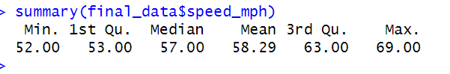

3.2 Data Classification by Speed Ranges

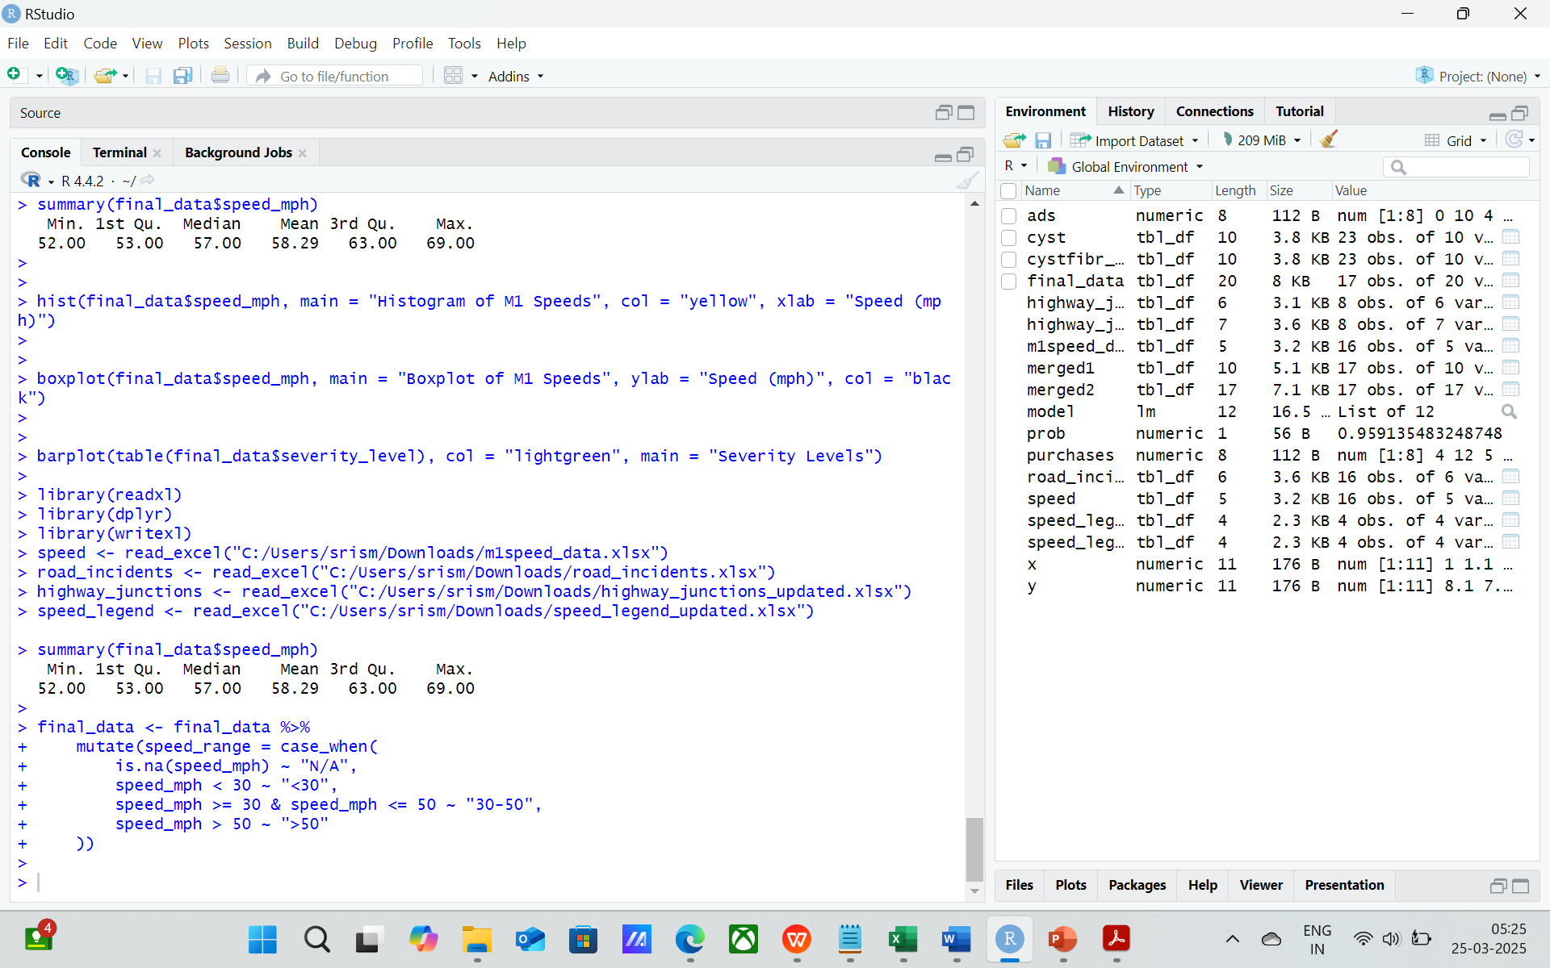

3.3 Data Visualisation

CODE:



OUTPUT:

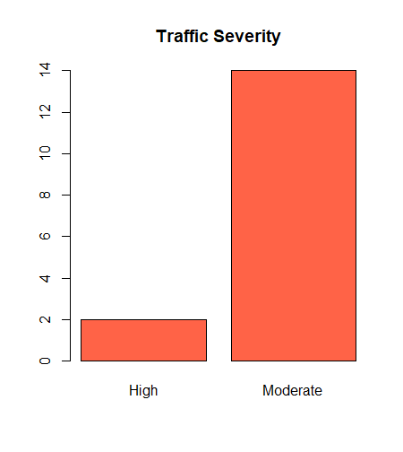

**4. Key Insights & Findings**

All sampled junctions maintained a steady flow of traffic above the posted limit, their velocities a testament to the smooth operation of that busy motorway system. The slightest of impedances was revealed at Coventry J17, where a limited opening hampered the normally expeditious passage to a low of only fifty-two miles per hour. Throughout much of the monitored areas, the predominant disruption was deemed "Road Maintenance of Some Importance", disturbances that appeared to emerge with disturbing repetition. For the busier places near Luton, Milton Keynes, and St Albans, their speeds eclipsed sixty miles per hour, rendering them appropriately suited to the well-timed conveyance of products. Certain junctions like the crossing of routes twelve and the spur of fifteen A found themselves plagued by resurfacing duties so often that exceptional precautions in rerouting may prove essential to avoid delays. Elsewhere, minor roads took their turn with troubles as potholes prospered prolifically regardless of repairs, forcing evasive maneuvers for uneasy drivers. Additionally, the interdependence between constructions and movement underscored the requirement for heightened collaboration and forewarning to relieve burdens for everyone.

**5. Implications for Delivery & Logistics**

While the current traffic conditions on the M1 indicate deliveries should remain on schedule, some challenges may emerge. Sections prone to delays, like junction 17, deserve heightened attention for alternative routing as needed. Though places like Milton Keynes and St Albans see fewer problems overall due to lower densities, stopping briefly could help plan routes more precisely through predictive analysis of regular dataset updates, minimizing disruptions from unforeseen developments.

**6. Relevant Background Research**

The United Kingdom's Department for Transport's guidelines state that average speeds exceeding 50 miles per hour on highways normally indicate traffic moving freely with few barriers to travel. Constant updates on present road situations are progressively integrating into logistics and fleet administration programming, spontaneously modifying transportation courses presently to enhance driving occasions and fuel proficiency in light of moment by moment movement situation details. The Traffic England website, continually aggregating updates from a network of highway surveillance cameras and sensors, has become a crucial online resource for transportation and shipping companies to carefully orchestrate consignment transport schedules well in advance while monitoring major motorway arteries for any unexpected delays or lane restrictions that could postpone deliveries or inflate operating costs.

**7. Conclusion**

This analysis of travel times along the M1 northbound route showcases the usefulness of ongoing speed observation for delivery operations management. Aggregating traffic flow statistics, noted road disruptions, and route attributes into an integrated set afforded discernable learnings regarding flow tendencies and impediment probabilities. The outcomes imply that the bulk of the M1 presents a advantageously placid passageway for transport logistics during the time of inspection, with sparse congestion detected.